**SPACE FOX**

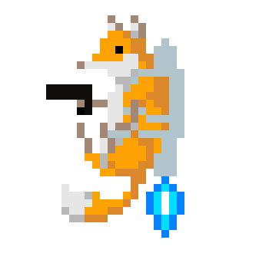

By Ethan Gregory

The genre of this game is a single player 2D shooter “endless runner.” A similar game is [*Jetpack Joyride*](https://youtu.be/OhU7tLtOIgE?t=194)*,* which is similar as the player controls a character with a jetpack who moves up and down and must dodge obstacles coming their way. In the case of SPACE FOX, the player takes control of a fox wearing a jetpack.

The in-game obstacles consists of asteroids of different shapes. The player must last as long as possible to get a high score. The player’s score will gradually go higher the longer they survive. It’s an arcade-style game, as the goal is to last as long as possible to get the highest score as there isn’t a single “win condition.” It is a game of endurance and reaction time.

The player has three health points, if the player gets hit by an asteroid, they lose one health point. If they get hit three times, they get a game over. The main controls of the player consists of moving up and down to dodge asteroids coming their way. The asset for the character the player controls can be found [here](http://pixelartmaker.com/art/61e78f9c445e4a1). The asset for the asteroids can be found [here.](https://assetstore.unity.com/packages/2d/environments/2d-pixel-asteroids-136477)

A walkthrough of the game is pressing start on the title screen, starting the game. The player then needs to dodge or shoot asteroids coming their way, trying to avoid getting hit and losing health points. If the player is hit three times, they get taken to the game over screen and can see their score. If the player presses enter, they are taken back into the game and can try again. There will also be credits which can be accessible on the title screen by pressing the space key.

Time spent on features:

Player Object: ~7 minutes

Obstacle Object: ~5 minutes

Projectile Object: ~20 minutes  
Game Over screen: ~15 minutes

Spawner: ~25 minutes

Time spent on programming scripts:

DetectCollisions: ~15 minutes

Spawner: ~20 minutes

SpawnPoint: ~5 minutes

Movement: ~15 minutes

Obstacle: ~10 minutes

Player: ~50 minutes

GameOver: ~20 minutes

Features left to implement:

Sprites (estimated 30 minutes)

Laser sound (estimated 40 minutes)

Moving background (estimated 30 minutes)

Title screen (estimated 20 minutes)

Animations (estimated 40 minutes)

New features (Milestone 2):

Sprites: ~30 minutes

Music: ~10 minutes

Health UI: ~15 minutes

High score UI (in-game, game over screen): ~15 minutes

Destroy Object after 5 minutes: ~5 minutes

Time spent on programming scripts (Milestone 2)

Comments: ~10 minutes

Score: ~10 minutes

Player: ~20 minutes

GameOver: ~5 minutes

New features (Milestone 3):

Sound: ~20 minutes

Repeating background: ~60 minutes (tried to make it perfect but couldn’t)

Title screen: ~10 minutes

Credits screen: ~10 minutes

Font: ~10 minutes

Time spent on scripts (Milestone 3)

Credits: ~5 minutes

Title: ~5 minutes

Player: ~60+ minutes (most time spent on trying to make it so the lasers don’t make the game too easy but I wasn’t able to find a solution).

Obstacle: ~30 minutes

Removed features (Milestone 3):

Projectiles (Made the game too easy and as a result, made the game boring to play)